# Butterfly Museum Specimens (Answer Key)

Morphological Responses to Climate Change: A Case Study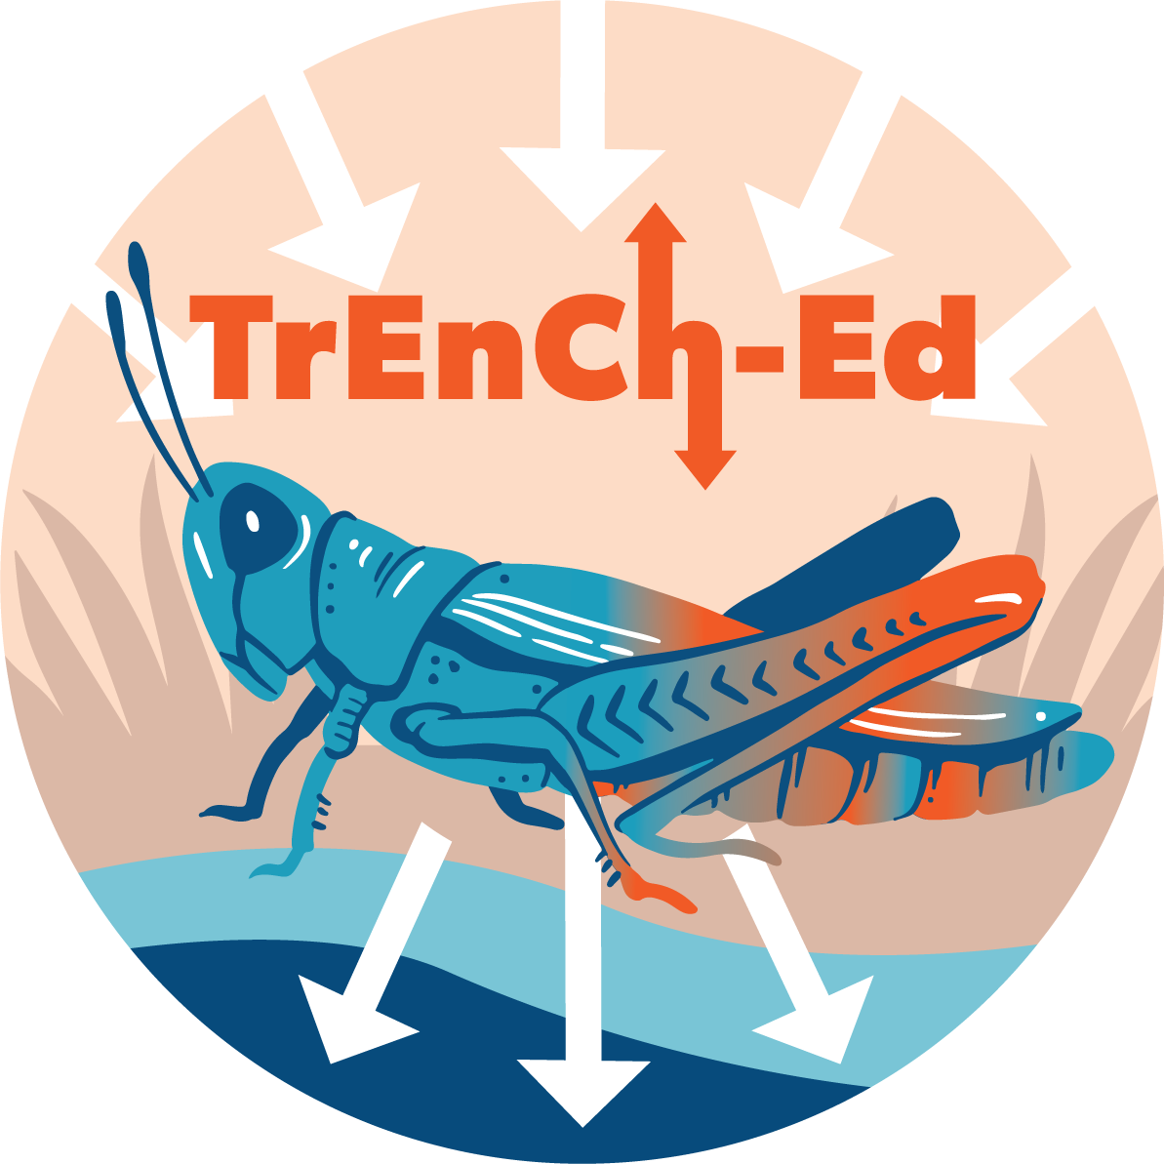

## [Link to the visualization](https://huckley.shinyapps.io/butterflies/)

## [Link to TrEnCh-Ed](https://trench-ed.github.io/#)

## Objectives

* Analyze case study data to create an explanation about how climate might influence species such as the *Colias* butterflies.
* Understand how thermoregulatory traits (e.g., coloration, size) influence how organisms interact with their environment.
* Examine how climate change can drive changes in thermoregulatory traits

## Cross-cutting concepts -- *Next Generation Science Standards*

* Patterns
* Cause and effect
* Energy and Matter
* Structure and function
* Stability and change

## Cross-cutting concepts -- *Other*

* Change vs variability
* Data reasoning

## Standards

Life Science Standards (LS)

|  |  |
| --- | --- |
| **Performance Expectation** | **Students who demonstrate understanding can...** |
| HS-PS2-2 | Use mathematical representations to support and revise explanations based on evidence about factors affecting biodiversity and populations in ecosystems of different scales. |

Advanced Placement Environmental Science

|  |  |
| --- | --- |
| 2.6 - Describe how organisms adapt to their environment. | * **ERT-2.H.1-** Organisms adapt to their environment over time, both in short- and long-term scales, via incremental changes at the genetic level. * **ERT-2.H.2** - Environmental changes, either sudden or gradual, may threaten a species’ survival, requiring individuals to alter behaviors, move, or perish. |

## Background

Read the introduction to the visualization and answer these background questions below.

### Museum specimens hold clues to organisms’ physical changes

1. What response to recent climate change did researchers document in many species?

Many species had decreased overall body size.

1. What do they think are the two reasons for this response?

(1) It’s easier to cool down due to the large surface area to volume ratio.

(2) Warmer temperature lets them grow faster and reach adulthood at a smaller size.

### Warmth is life or death for *Colias* butterflies

1. What is the habitat of the *Colias* butterflies?

Mountains

1. Define thermoregulation:

Maintaining ideal body temperature.

1. How do *Colias* butterflies thermoregulate?

They thermoregulate by exposing their underwings to the sun, which are darkly pigmented to absorb solar radiation more efficiently.

### Pulling data out of specimen drawers

1. Where were the *Colias* butterflies found in this study?

Subalpine and alpine meadows in the Rocky Mountains at many elevation levels.

### Taking trait measurements

1. Summarize how MacLean measured the three morphological traits.

She used a program to calculate the melanism in the underside of the hind-wing. She also measured their forewing length and setae hair length (also called “fur”).

1. In the next and final set of questions, you will be analyzing variables about the *Colias* butterflies. Give a definition of each of the following measurements and how they were collected using information given in the reading.
   1. Seasonal temperature:

Overall spring and summer temperatures. Taken from nearby weather stations. For populations at high elevations where there are no stations, proper adjustments were made to simulate an approximate climate using data from stations at low elevation.

* 1. Pupal temperature:

The temperature during pupation. It is important because butterfly wing pigmentation is generally reliant on this temperature. A cooler pupal temperature corresponds to darker wing pigmentation to absorb more solar radiation and vice versa.

* 1. Wing melanism:

The darkness of the underwing. A darker underwing allows a butterfly to control its temperature by absorbing solar radiation while lateral basking.

* 1. Forewing length:

The length of the forward wing. It can be a metric to measure the body size of a butterfly population.

* 1. Setae length:

Length of the longest fur between the first and the second leg. Longer setae allow the butterfly to stay warmer.

## Questions

In this exercise, you will be able to create graphical representations using multiple variables. You will be attempting to evaluate a graph and then will be able to make changes according to your hypotheses. Try to answer some of the following questions by changing the data you plot. For each question, consider whether you see the same patterns at all three sites, or if different populations respond differently. Recall how each population occupies a different elevational range. How might this affect their responses?

1. What is the variable present on the x-axis (horizontal)?

Year

1. Change the y-axis to represent the seasonal temperature. Have spring and summer temperatures increased over the years? If so, at which sites?

All three sites have seen the temperature rise.

1. Change the y-axis to measure the forewing length. Has forewing length decreased over the years? If so, at which sites?

Forewing length has decreased in the Canadian Rocky Mountains.

1. Have the butterfly wings lightened over the years?
   1. To answer this question, what should you change on the graph to measure the pigmentation of the butterfly wings?

Change the y-axis to wing melanism

* 1. Make this change to the graph. Have the butterfly wings lightened over the years?

In the Canadian and Northern Rocky Mountains, wings have lightened. In the Southern Rocky Mountains, wings have darkened.

1. Using the visualizations, have forewings or setae length changed over the years?

Forewings have increased in length at mid and high elevations while they have decreased at low elevations.

We see no change in setae length at low elevation although it has increased at mid and high elevations.

1. How do spring and summer temperatures affect the day of year when butterflies reach adulthood?

Warming temperatures correspond with butterflies reaching adulthood earlier in the season.

## **Analysis**

It is difficult to predict how individual populations will behave in the face of change. It is important that data are collected to allow for testing of both simple and complex hypotheses to help forecast responses to climate change.

Using the visualization in the section “Exploring butterfly morphological data”, create and test your own hypothesis. Don’t make changes until you have a prediction!

If you need additional hints, fill out the following sections:

* What is your prediction/hypothesis?
* What is your chosen x-axis variable?
* What is your chosen y-axis variable?

Run your test using the visualization.

* What did you observe?
* Was your hypothesis correct? Explain.